When making games it’s common to run into the problem of having several scenes to render, such as a main menu, options menu, the game, etc. The solution is to make a scene manager. This is a class which keeps track of the different scenes of your game and switches between them. Allowing you to easily changing the control schemes, assets, etc.

Firstly you’ll need to make an abstract BaseScene class. This will need methods for creating and destroying the scene as well as getting the scene type. You may also include and variables which will be needed for your scenes such as a camera or engine.

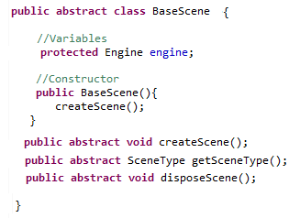

Next you will need to make your SceneManager class. This should be able to see your BaseScene class. Create any scenes you wish to make as a BaseScene variable. You may also use an enum to pass in which scene you are using and a currentScene variable to set the scene.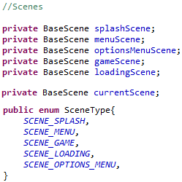

Next we just need to write methods for initialising each scene. It is also important to dispose of the previous scene as to free up memory. (Note: you don’t need to use a resources manager to load assets.)

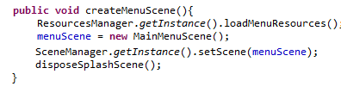

Within each separate BaseScene we then specify the logic which that scene requires.